Air Quality Prediction Using Machine Learning

Suresh kumar Mandala
Department of computer science and Artificial intelligence,
SR university, warangal-506371 Telangana,
mandala.suresh83@gmail.com

Swathi Balija
Department of Computer Science and Artificial Intelligence,
SR University, Warangal-506371 Telangana,
jrswathi.hi@gmail.com

Chittimalla.Nikshitha
Department of computer science and Artificial intelligence

SR University, Warangal-506731 Telangana,

2203a52144@sru.edu.in
Theneti srividhya
Department of computer science and Artificial intelligence
SR University, Warangal-506731 Telangana,
t.srividhyareddy@gmail.com

Abstract— This study inspects a vast dataset of meteorological and air pollution information that was obtained from Kaggle and covers a nine-year time span. The analysis of this dataset reveals complex trends and important variables that directly affect air smog foci. Applicable qualities are painstakingly picked using demanding preprocessing techniques like head part examination (PCA) and joining investigation. Among the machine learning methods used in the study are K-Closest Neighbors (KNN), Support Vector Machine (SVM), Linear Regression, Logistic Regression and Multiple Regression. The Python Scikit-learn module works with the presentation valuation of these models utilizing various procedures, including r2 score, mean out and out botch, mean inside and out rate goof, and root mean square mistake. Strangely, for this dataset, troop tactics end up being the best models.

Keywords— huge information examination, information-driven air quality assessment, practical AI, low asset locations, air quality anticipation, cost-adequacy, and AI

Introduction
Growing worry about air pollution in recent decades has highlighted its noteworthy effects on environmental sustainability and public health worldwide. India stands out in this context, harassed with widespread issues related to air quality that are made inferior by the country's fast urbanization, industrialization, and population expansion. The damaging impacts of air pollution become more clear as urban centers grow and commercial activity increases, necessitating immediate action to monitor and lessen its harmful effects.
In view of this, the emergence of analytical technology powered by machine learning signals a paradigm shift in the management and forecasting of air quality. In contrast to predictable approaches, which frequently depend on oversimplified models and static data analysis, machine learning provides a dynamic and data-driven technique that may identify subtle patterns and subtleties within sophisticated atmospheric systems. Through the utilization of extensive databases including real-time information on human caused activities, pollutant concentrations, and climatic environments, machine learning algorithms may provide predictive models and actionable insights that are previously unreachable in terms of exactness and stability.
Given complexity of air contamination, a detailed grasp of its origins, makeup, and spatiotemporal undercurrents is required. Although automobile exhaust and industrial emissions are the main reasons of air contamination in the environment, a variety of human activities, such as garbage ignition, agriculture, and residential energy use, causes atmospheric worsening. Furthermore, managing air quality and protecting the health of the public are complicatedly challenged by the growth of gaseous pollutants including fine particulate matter (PM2.5), volatile organic compounds (VOCs), and nitrogen oxides (NOx).
Air pollution has long-term effects on the ecosystem, increasing the threat of climate change, biodiversity loss, and ecological degradation, in addition to its direct health effects. The complex web of interrelated environmental processes is highlighted by the interaction between air pollutants and climatic events, importance the need for comprehensive justification methods and longstanding policy interpositions.
With these needs in mind, our research aims to clarify the complex dynamics of air pollution in India by utilizing cutting-edge machine learning methods to identify underlying trends, predict future developments, and guide evidence-based actions. We seek to revolutionize air quality management by combining multidisciplinary knowledge with state-of-the-art computational techniques, defending future generations' health and the purity of our surroundings.

Literature Survey
Kumar et al's The Air Quality File (AQI) and six years of air contamination data in Indian urban communities have been examined., focusing on twelve air poisons. The dataset was cleaned and preprocessed before data visualization techniques were used to find hidden patterns and trends. Moreover, the paper tends toward information lopsidedness through resampling strategies and looks at the presentation of five famous ML models utilizing standard measurements. On both the train and the test sets, classical statistical error metrics were used to evaluate the precision of various machine learning (ML) models. The XGBoost model exhibited the most noteworthy precision, while the SVM model had the least. Metrics like MAE, RMSE, RMSLE, and R2 were looked at to see how well ML models performed in comparison to one another. In light of these measurements, the XGBoost model was viewed as the best, generally speaking, entertainer, accomplishing ideal qualities during both preparation and testing stages.

Doreswamy HKS et al.'s concentrate on presents AI models for investigating air contamination utilizing TAQMN information from Taiwan. The dataset ranges from 2012 to 2017 and incorporates records from 76 Air Contamination Stations. The focal point of the review is on anticipating particulate matter PM2.5 levels utilizing AI models, with assessment in view of measurable measurements like MAE, MSE, RMSE, and R2. The outcomes demonstrate the proposed models beat past models, with real and anticipated values showing close arrangement. In view of the assessment, the review reasons that the angle-supporting regressor model is the best at anticipating air contamination on the TAQMN dataset.

Madan et al's. propose the meaning of expecting air quality as a effect of its basic effect on human richness and environment. Different air pollutants like carbon dioxide, nitrogen dioxide, and carbon monoxide from sources like consuming oil gas, coal, and vehicles add to air tainting. By dissecting datasets from sources like Kaggle and air quality checking destinations, AI calculations play an vital role in determining the air quality record. The paper indicates usage of Traditional Backslide, Decision Tree, Erratic Forest Area, Imitation Mind Association, and Support Vector Machine estimations for air quality assumption. Air tainting can provoke an extent of clinical issues, from throat magnification to difficult diseases like respiratory issues, cell breakdown in the lungs, and psyche disorders, underlining the prerequisite for defilement control measures and care campaigns. Mandatory toxins like ground-level ozone and destructive downpours are discussed as supplementary allies of air tainting in the paper. Various models like Erratic Forest, Backslide Models, and Cream Tree Models are surveyed for their precision in imagining air poison levels in different regions.

Methodology

A. About the Dataset
Name of Data set: Air Quality
Taken From: Kaggle website

A combined all out of 9358 amounts, or hourly found the middle value of readings from five metal oxide synthetic sensors integrated into an Air Quality Compound Multisensory Gadget, contain the dataset that was gained by means of UCI AI. The device was intentionally placed at ground level in an urban area known for its high pollution levels, principally from vehicle traffic.
The air quality substance sensor reactions from field organizations are given by means of an comprehensive, drawn-out dataset that was gathered between Walk 2004 and February 2005. To decide the standard for ground truth guesstimates, hourly found the middle value of groupings of different poisons, like CO, non-methanic hydrocarbons, benzene, hard and fast nitrogen oxides (NOx), and nitrogen dioxide (NO2),and data from a co-found locus guaranteed analyzer. Cross-responsive qualities are recognized in the dataset's metadata data.

Preprocessing

A. Splitting the Dataset

Preparation steps were taken to make sure the dataset was ready for predictive modeling. To avoid conciliatory the dataset's integrity, missing values were imputed using the mean value of each feature column. The dataset was smoothed out by eliminating superfluous segments like "Date" and "Time" and focusing just on important factors that impacted the objective variable. To keep highlight sizes reliable all through the dataset, mathematical elements were normalized, utilizing highlight scaling. Similar preprocessing was applied to the ideal variable, CO focus, with mean attribution used to attribute missing information to empower exact model preparation. These preprocessing stages joined to ensure that the dataset was ready for later model evaluation and preparation. Utilizing a broad number of models, each with exact properties and conventions, the impartial

Stimulation

A.Linear Regression

Linear Regression is a genuine strategy used to lay out the overtone between a dependent variable and something like one free element. It expects an immediate association between the elements and plans to find the best-fitting straight line to depict the data. The condition shows the connection between the reliant variable Y and the free factor X in its most straightforward structure, called basic Linear Regression: 𝑌=𝛽0+𝛽1𝑋+𝜀
Where:
• Y is the contingent variable.
• The allowed factor is X.
• The catch, or the value of Y when X is zero, is 0
• 1 is the inclination, exhibiting the change of Y for a one-unit change in X. •
is the goof term, tending to the divergence between the saw and expected potential gains of Y. Techniques like the least squares approach are utilized to assess the coefficients 0 and 1 from the information. The connection between the reliant variable (Y) and the various autonomous factors (X1, X2, Y) in different straight degenerations is addressed by the successive condition:

E = +1X1+2X2+...+n Xn

where the coefficients' significance remains nearby that of a direct straight relapse. A model fit assessment is essential in linear regression.

To evaluate model's decency fit, measurements like F-measurement, changed R-squared, and R-squared are every now and again utilized. These metrics reveal extent to which the independent variables can descripte for the variance in the dependent variable. The results of decline think on showing the course and level of the relationship between the factors.

A positive coefficient of 11 for the independent and dependent variables, for instance, indicates a positive association. A negative coefficient, then again, indicates a terrible relationship. Furthermore, speculation tests might be utilized to assess the meaning of the coefficients. To review, straight degeneration is a powerful technique for sorting out and estimating the connection between factors. Through the assessment of coefficients and model fit measurements, scientists can get huge information about the factors affecting the relieving variable. The results acquired by utilizing straight reversions to the air quality datasets were as per the following:

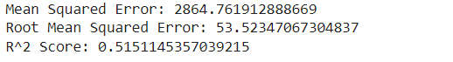

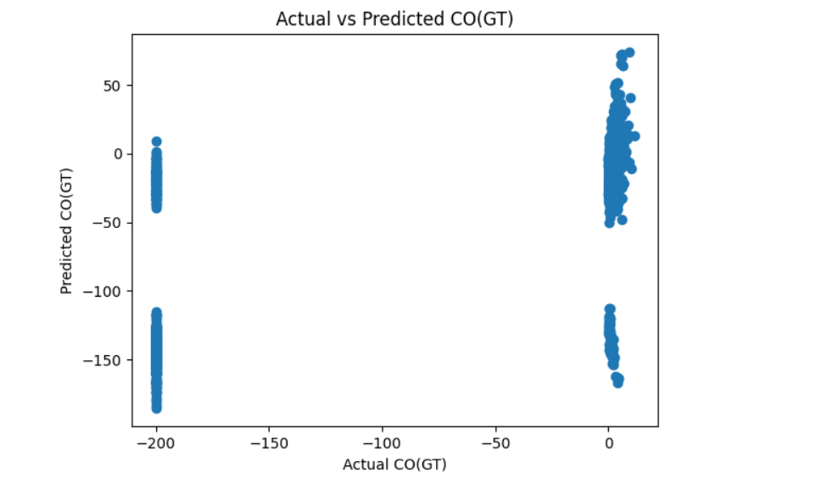

B. Logistic Regression

The essential disappearing model has its premise in the possibilities of a 2-level significance of interest. For ease, I acknowledge that we have relegated one of the outcome levels the event of interest, and in the valuable text we will fundamentally call it the event. The possibilities of the event are the extent of the probability of the event happening, isolated by the probability of the event not happening. Chances are frequently used in betting, and "fair chances to break even" (Odds=1) refer to the event occurring only occasionally.

On the off chance that you moved a lot of numbers on a solitary kick in the bucket, this would be the situation. Since moving a number 5 is two times as possible as moving a number 5 or 6, the chances of moving a number 5 are 2. Equity in the possibilities is considered to be by taking the correlative, and the possibilities moving fundamentally a 5 would be 0.5 (=1/2).

The determined Logistic model takes the ordinary logarithm of the possibilities as a backslide capacity for the pointers. With 1 pointer, X, this takes the design ln[odds(Y=1)]=0+1X, where ln addresses the standard logarithm, Y is the outcome and Y=1 when the event happens (versus Y=0 when it doesn't), β0 is the trick term, and β1 addresses the backslide coefficient, the change of the logarithm of the possibilities of the event with a 1-unit change in the marker X. The stipulation in logarithms of 2 characteristics is comparable to the logarithm of the extent of the 2 characteristics, so by taking the exceptional of β1, we get the extent of the probabilities (the possibilities extent) connecting with a 1-unit change in X.

C. Support Vector Machine

SVMs are commonly used for inside portrayal issues. They perceive two classes by finding the ideal hyperplane that reinforces the edge between the closest significant snippets of data from opposite classes. The number of components in the data determines whether the hyperplane is a line in a 2-D space or a plane in a n-layered space. Since various hyperplanes can be found to isolate classes, supporting the edge between centers enables the estimation to find the most ideal decision limit between classes.

Consequently, it enables it to summarize well with new data and make exact portrayal assumptions. The lines that are close by the ideal hyperplane are alluded to as assist vectors, as these vectors are going through the data centers that choose the maximal edge. The SVM computation is comprehensively used in computer-based intelligence as it can manage both immediate and nonlinear request tasks. Be that as it may, portion capabilities are used to change the information into higher-layered space to empower direct detachment when the information is not straightly divisible.

The "bit stunt" refers to this use of pieces' capabilities. The choice of portion capability, such as direct parts, polynomial parts, spread premise capability (RBF) portions, or sigmoid bits, is determined by information assets and the specific use case. Direct SVMs are used with straightly removable data; this suggests that the data need to go through no progressions to disconnect the data into different classes. Teacher Patrick Winston from MIT uses the relationship between fitting the largest conceivable road to illustrate this quadratic improvement problem. The choice limit and backing vectors structure the presence of a road. Genuinely, this segregating hyperplane can be tended to as:

wx + b = 0

where the predisposition term is b, x is the information vector, and w is the weight vector. Hard-edge grouping and delicate edge arrangement are the two methods for determining the edge, or the greatest distance between classes. In case we use hard-edge SVMs, the data centers will be perfectly secluded past the assistance vectors, or "off the street" to happen with Educator Hinton's relationship. This is tended to with the recipe, (wxj + b) yj ≥ a, and a short time later the edge is delayed, which is tended to as: max = a/||w||, where an is the edge projected onto w. Coming up next were the results gotten by applying Support Vector Machine to the air quality datasets:

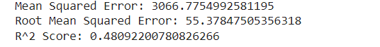

D. K- Nearest Neighbors

K-Closest Neighbors (KNN) is a standard AI method which has been reached out to huge-scale information mining activities. The thought is that one uses a lot of preparation for information, where every information point is portrayed by a bunch of factors. Practically, each point is plotted in a high-layered space, where every pivot in the space compares to a singular variable. Whenever we have new (test) data of interest, we need to figure out the K closest neighbors that are nearest (ie, most "comparative" to it).

The number K is regularly picked as the square base of N, the complete number of focuses in the preparation informational index. (As a result, K = 20 if N is 400). KNN is reasonably upfront and enjoys the benefit of being nonparametric. That is, the strategy can be utilized in any event, when the factors are straight out; however, assuming you are involving numeric factors in the blend, it is ideal to normalize them to take out contrasts in scale. The test is that when the quantity of information focuses is extremely huge (e.g., an internet based book retailer has a great many books), unique techniques should be utilized to quickly look through the space and see as the "most comparative" things. Generally, some type of precomputation is utilized, for instance, ordering.

Moreover, as opposed to utilizing every one of the germane pieces of information, chosen information focuses that are illustrative of individual groups ("models") might be utilized to work with the hunt against another thing, and afterward the precomputed neighbors of the most comparative model are likewise shown.

Basically, attempting to weaken the quantity of aspects with a strategy like SVD/LSI and afterward plotting the data of interest in the decreased variable space might bring about serious additions in execution. The outcomes acquired by applying K-Closed Neighbors on the air quality datasets:

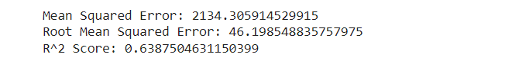

E.Multiple Linear Regression:

Abundant direct declines are a factual technique that includes utilizing at least two free factors to foresee the result of a dependent variable. This method permits experts to survey the variety in model and overall commitment of every autonomous mutable to an absolute change. Numerous deteriorations can take two structures: straight decline and non-direct relapse. The multiple linear regression formula is as follows:
yi=β0+β1xi1+β2xi2+...+βpxip+ϵ
Where:
• 𝑦𝑖 is ward or projected variable.
• 𝛽0 is the y-block, addressing the worth of y when all free factors are 0.
• β1,β2,...,βp are the Regression coefficients, demonstrating the change in y comparative with a one-unit change in every free factor.
• xi1,xi2,...,xip are independent factors.
• ϵ is model's irregular mistake period. Various declines accepted a few key guesses:
Statisticians can use information about another variable to predict value of one variable using simple linear regression. Direct relapse actions to lay out the connection between the two factors along a straight line. Different Regression is a kind of regression where the dependent variable shows a conventional relationship with at minimum two free issues.

Non-linearity, in which the independent and dependent variables do not survey a straight line, is another possibility. Together direct and non-straight regression track a specific reaction utilizing at least two factors realistically. But non-direct relapse is normally challenging to execute since it is made from assumptions derived from investigation.

Together linear regression, multiple linear regression yields the following:

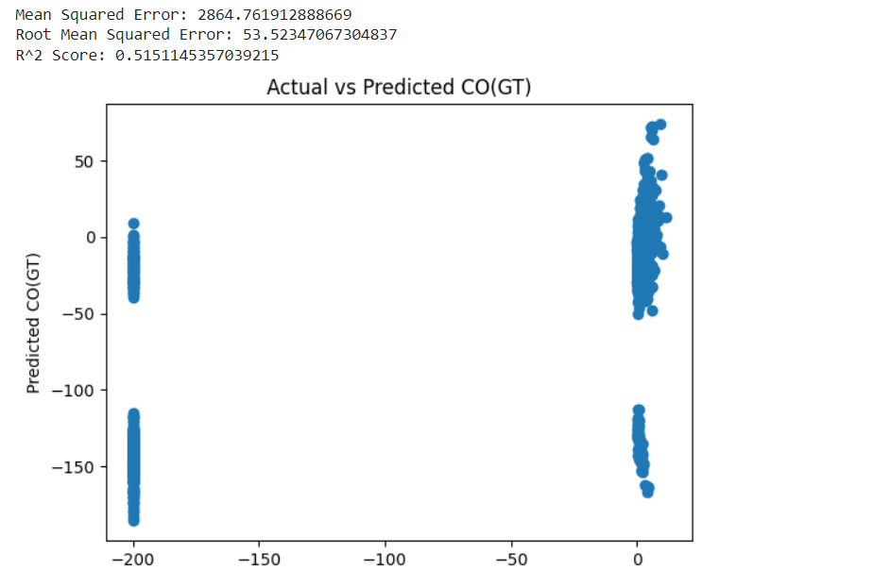

Model Evaluation

Shifting models assessed on our dataset have differing performance results. Despite its general use, the results of linear regression were not ideal. This may be a direct result of linearity as a rule, which makes it hard to address the intricacy of our information completely.

In spite of its convenience in ordering events, calculated relapse performed inadequately, showing its cutoff points in dealing with the highlights of our dataset. Alternately, SVM showed adequate, however not exactly adequate execution, demonstrating that it experienced issues precisely catching the hidden examples. When contrasted with different models, KNN showed nearly incredible anticipated precision, making it a champion entertainer. It varies from others because of its ability to recognize the mind boggling designs inside the information.

While performing somewhat well, multiple linear regression did not adequately capture the data's complication, as did linear regression. Chance part capability endeavors yielded results that didn't broadly work on model execution, while troupe-based approaches showed guarantee in wording on forecast exactness enhancement. SVM, KNN, and ensemble-based gets closers all established varying degrees of success, but traditional linear and logistic regression models performed poorly. This pressures that it is so significant to pick models that are appropriate for the dataset to have the best likely execution.

Conclusion
MODELS | RMSE | R^2
Linear | 53.52 | 0.51
Logistic | 2925.70 | -5725
SVM | 55.3 | 0.48
KNN | 46.19 | 0.63
Multiple | 53.5 | 0.5

Model Evaluation Metrics

Utilizing a dataset I downloaded from Kaggle, I assessed various AI models for air quality expectation in this exploration study. The models that were inspected incorporated different direct relapses, calculated degenerations, support vector machines (SVM), k-closest neighbors (KNN), and straight relapse, among other conventional methodologies.

After conducting an in-depth analysis, I discovered that the models produced distinct performance outcomes. All the same being generally utilized, calculated degeneration and direct degeneration both showed hardships as far as catching the mind-boggling designs present in the air quality information.

Their moderate R^2 scores and relatively high upsides of 53.52 and 2925.70, separately, featured the troubles brought about by the complexities of the dataset. In spite of its adaptability, SVM produced an R2 score of 0.48 and an RMSE of 55.3, indicating reasonable but insufficient prediction accuracy.
KNN, then again, showed additional enriching results, with a lower RMSE of 46.19 and a superior R^2 score of 0.63, demonstrating that it was effective in recognizing fundamental examples in the dataset. Like its less convoluted cousins, numerous straight setbacks neglected to catch the difficulty of the dataset, bringing about a R^2 score of 0.5 and a RMSE of 53.5.

It couldn't achieve the highest level of exactness in air quality conjectures, in spite of the fact that it showed a respectable degree of prescient capacity. The significance of employing modeling strategies that are appropriate for the dataset's features is highlighted by these findings. KNN showed up as a decent competitor for exact air quality estimations, featuring its true capacity for use in environmental exploration and prescient displaying exercises, while standard direct models were intolerable.

References

- Kumar, K., Pande, B.P. Air pollution prediction with machine learning: a case study of Indian cities. Int. J. Environ. Sci. Technol.
(2022). https://doi.org/10.1007/s13762-022-04241-5
- Doreswamy HKS, Yogesh KM, Gad I (2020) Forecasting Air pollution particulate matter (PM2.5) using machine learning regression models. Procedia Comput Sci 171:2057–2066. https:// doi. org/ 10. 1016/j. procs. 2020. 04. 221
- Madan, Tanisha, Shrddha Sagar, and Deepali Virmani. "Air quality prediction using machine learning algorithms–a review." In 2020 2nd International Conference on Advances in Computing, Communication Control and Networking (ICACCCN), pp. 140-145. IEEE, 2020.
- V. M. Niharika and P. S. Rao, “A survey on air quality forecasting techniques,” International Journal of Computer Science and Information Technologies, vol. 5, no. 1, pp.103-107, 2014.
- E. Kalapanidas and N. Avouris, “Applying machine learning techniques in air quality prediction,” in Proc. ACAI, vol. 99, September 1999.
- D. J. Nowak, D. E. Crane, and J. C. Stevens, “Air pollution removal by urban trees and shrubs in the United States,” Urban Forestry & Urban Greening, vol. 4, no. 3, pp. 115-123, 2006.
- T. Chiwewe and J. Ditsela, “Machine learning based estimation of Ozone using spatio-temporal data from air quality monitoring stations,” presented at 2016 IEEE 14th International Conference on Industrial Informatics (INDIN), IEEE, 2016.
- Y. Zheng, X. Yi, M. Li, R. Li, Z. Shan, E. Chang, and T. Li, “Forecasting fine-grained air quality based on big data,” in Proc. the 21th ACM SIGKDD International Conference on Knowledge Discovery and Data Mining, pp. 2267-2276, August 10, 2015.
- C. J. Wong, M. Z. MatJafri, K. Abdullah, H.S. Lim, and K. L. Low, “Temporal air quality monitoring using surveillance camera,” presented at IEEE International Geoscience and Remote Sensing Symposium, IEEE, 2007.
- J. Gao, C.-L. Xie, and C.-Q. Tao, “Big data validation and quality assurance - issues, challenges, and needs,” IEEE Symposium on Service-Oriented System and Engineering, IEEE Computer Society, Oxford, UK, April, 2016.
- L. Xiang, L. Peng, Y. Hu, J. Shao, and T. Chi, “Deep learning architecture for air quality predictions,” Environmental Science and Pollution Research, vol. 23, no. 22, pp. 22408-22417, 2016.
- ] W. F. Ip, C. M. Vong, J. Y. Yang, and P. K. Wong, “Least squares support vector prediction for daily atmospheric pollutant level,” in Proc. 2010 IEEE/ACIS 9th International Conference on Computer and Information Science (ICIS), pp. 23-28, IEEE., August 2010.
- R. Yu, Y. Yang, L. Yang, G. Han, and, O. A. Move, “RAQ–A random forest approach for predicting air quality in urban sensing systems,” Sensors, vol. 16, no. 1, p. 86, 2016.
- A. Sarkar and P. Pandey, “River water quality modelling using artificial neural network technique,” Aquatic Procedia, vol. 4, pp. 1070-1077, 201

Git hub link :
https://github.com/srividhya7/AIML-37/blob/main/AirQualityPredic.ipynb

